26
TOWN OF ULYSSES
10 Elm Street, Trumansburg, NY 14886
ulysses.ny.us

Town Supervisor (607) 387-5767, Ext 232 supervisor@ulysses.ny.us
Town Clerk (607) 387-5767, Ext 221 clerk@ulysses.ny.us
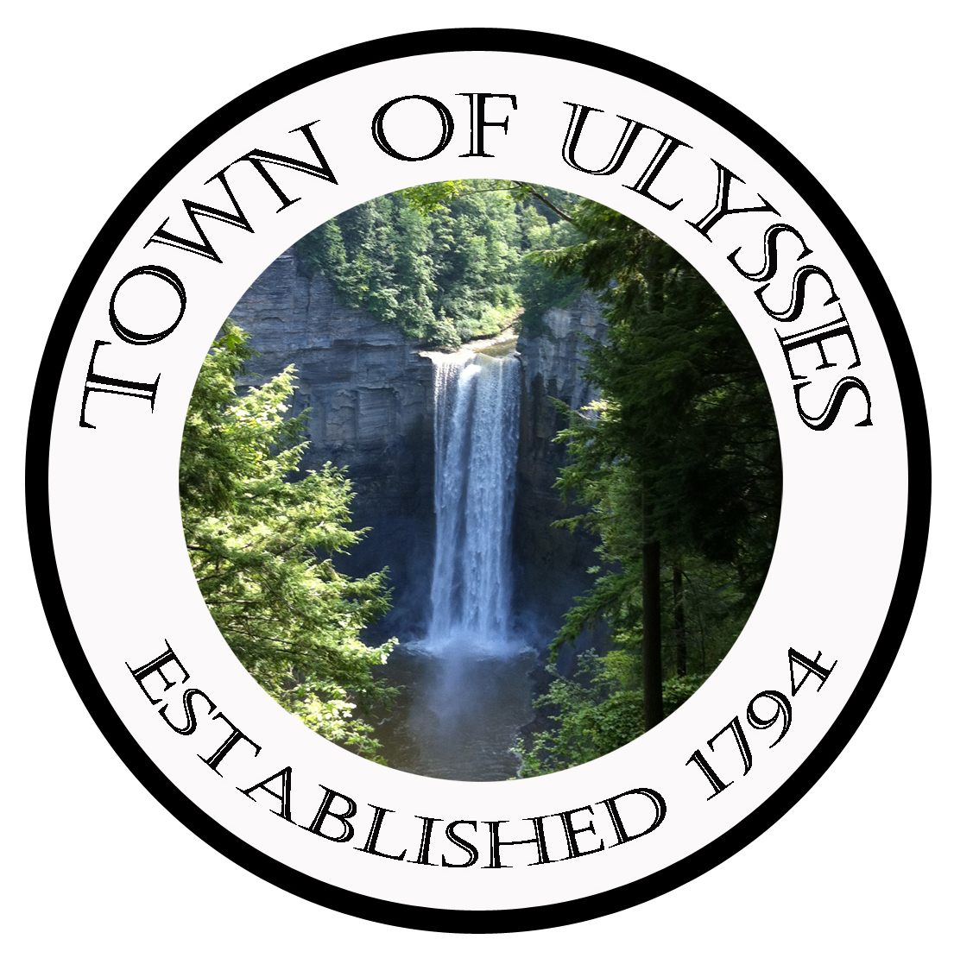

TOWN OF ULYSSES – WATER DISTRICT 3
OUT-OF-DISTRICT WATER USER AGREEMENT

This Agreement (“the Agreement”) is made effective ______________, 2020 by and between the TOWN OF ULYSSES (“the Town”), a municipal corporation with offices at 10 Elm Street, Trumansburg, NY 14886, and JENNIFER WRIGHT AND LARRY WRIGHT, (“the Owners”), residing at 3853 Colegrove Road, Trumansburg, NY 14886, the owners of a parcel of real property located on Colegrove Road, in the Town of Ulysses, County of Tompkins and State of New York, Town of Ulysses tax parcel number 26.-2-2.2 (“the Property”).

WHEREAS, the Owners request permission to connect to the existing Water District No. 3 in the Town of Ulysses (“the District”), owned and operated by the Town, and to extend water service to the Property; and

WHEREAS, after discussion and evaluation, the Town has prior hereto determined that forming a Town water district incorporating the property as indicated above would not be financially feasible and prudent; and

WHEREAS, on behalf of the District, the Town may benefit from the offsetting revenue from this Owner, and may benefit from the additional draw of water through the Water District water system which may improve water quality, and is willing to consent to the connection of the Property to the District (“the Connection”) on the terms set forth in this Agreement; and

WHEREAS, the Town has notified, sought, and received the consent of both the Town of Ithaca and Bolton Point regarding this connection;

NOW, THEREFORE, the parties agree as follows:

- Connection. The Town agrees to the Connection of the Property to the District.

- Specifications. All work pursuant to this Agreement shall be performed in compliance with the Town’s specifications.

- Out of District. Owners acknowledge that public water will be supplied to them despite the fact that the Property is located outside the boundaries of a Town water district, in order to enhance the health and welfare of the residents of the Property.

- Limited Duration; Availability. Owners acknowledge, for themselves and their successors in title, that the connection of the Property to the District will only be in effect until such time when the Property is included within the boundaries of either a new Town water district or the extension of an existing Town water district. If the Property is included in such new water district or extension of an existing water district at any time in the future, water service pursuant to this Agreement will be discontinued, and the Owners and their successors in title shall obtain water through such new or extended Town water district. Owners further acknowledge that any obligation of the Town to furnish water to the Property shall at all times be subject to and contingent upon its ability to obtain an adequate supply of potable water. The Town will make water supply available to all properties and users within the boundaries of the District, before making it available to Owners and any other out-of-district users. In the event of an inadequate water supply, Town may terminate this Agreement on sixty (60) days’ written notice to Owners.

- Access. Owners shall allow access to the property to the Town and its representatives at all reasonable times for purposes of reading the water meter and for purposes of making any inspections or repairs to the Connection.

- Installation and Maintenance.

- The Town will arrange for the Town water main to be tapped by a qualified water system operator near the end of the existing watermain pipe. The Town of Ulysses shall be responsible for directing a qualified contractor retained by the Owners, subject to Town approval, to install a 1” water service line and appurtenances on the north side of Colegrove Road from the watermain tap to a curb stop shut-off valve and meter pit to be located on the north side of Colegrove Road on Town property. The Owners will be responsible for these costs.

- The Owners shall be responsible for installing a water service pipe extension from the meter pit on the north side of Colegrove Road to the Owners residence, under the road through the Town right of way and across the Owner’s property. The installation plans and execution must adhere to the Town’s specifications.

- The Town shall be responsible for future maintenance and replacement of the water service line and appurtenances from the watermain to the meter pit, and including the meter pit.

- The owner shall be responsible for maintaining the water service pipe and appurtenances from the meter pit to their property.

- The Owners shall be responsible for paying additional fees as set forth in paragraph 7 below.

- Charges. Owners shall pay the following charges:

  - Connection fee: The Owners shall pay a connection fee in accordance with the Town of Ulysses schedule of fees for the District.

  - Operation & Maintenance (“O&M”) and Utility Service Fees: The Owners shall pay an O&M fee and a utility fee in lieu of debt service, which shall be calculated at 110% of the rate charged to other users in the District, and billed to the Owners in the same manner as other users in the District on their real property tax bill. The fee will be 110% of the charge per Equivalent Dwelling Unit (“EDU”) (calculated annually based on a property code assigned by Tompkins County Assessment) The Town, in its sole and absolute discretion, will have the right to re-evaluate the number of EDU’s assigned to the Property based on usage per year and/or property code.

  - Water usage: The Owners will be billed for their water usage on a quarterly basis. The rate at which the Owners will be charged will be 110% of the rate charged to other users in the District, to account for the infrastructure and debt payments other users in the District have already paid.

  - Any unpaid charges pursuant to this Agreement will be added to the Owners’ real property tax bill and collected in the same manner as for other users of the District.

- Memorandum of Agreement. A Memorandum of this Agreement shall be executed by the parties and recorded in the Tompkins County Clerk’s Office. The Owners will be responsible for paying the recording fees.

- Rules and Regulations. Owners acknowledge that they must comply with all applicable rules and regulations imposed by the Town with respect to the installation and maintenance of the Connection.

- Indemnification. Owners shall indemnify and hold the Town harmless from any and all losses, claims or expenses including reasonable experts’ fees and attorneys’ fees) arising out of the provision of water pursuant to this Agreement except to the extent that any such losses, claims or expenses (including reasonable experts’ fees and attorneys’ fees) or a portion thereof are found by a court of competent jurisdiction by final judgment after litigation to be the result of the negligence or willful wrongful act of the Town.

- Binding Effect. This Agreement shall inure to and bind all heirs, representatives, transferees, assignees and successors in interest and title to the parties hereto.

- Entire Agreement. This Agreement shall constitute the entire agreement of the parties regarding the Connection, and shall supersede any previous oral or written understandings. Furthermore, it may only be amended by a writing signed by the parties.

- Choice of Law. This Agreement shall be governed and construed under the laws of the State of New York without reference to choice of law rules and principles. Any litigation in connection with this Agreement shall be brought in a court of competent jurisdiction in Tompkins County.

- Gender and Number. The use of one gender in this Agreement shall include all others, and the use of the singular shall include the plural and vice versa.

- Notices and Communications. All notices and communications required under this Agreement shall be accomplished by the actual delivery to the parties’ mailing addresses set forth above. Any party may change their address for the purpose of this Agreement by giving notice in accordance with the provisions of this paragraph.

- Descriptive Headings. The descriptive headings of the various provisions of this Agreement are included for convenience only, and they are not intended to affect the meaning or construction of any of the provisions of this Agreement.

- Construction. Both parties to this Agreement have contributed substantially to the authorship of this Agreement and it is understood that this Agreement will not be construed against either party based on its authorship.

- Severability. If any provision of this Agreement is determined by a court of competent jurisdiction to be invalid or unenforceable, that shall not affect the validity or enforceability of the remaining portions of this Agreement.

- Further Acts and Assurances. The parties agree to perform such further acts and to execute and deliver such additional agreements and instruments from time to time as either may at any time reasonably request in order to assure and confirm unto such requesting party, the rights, powers and remedies conferred in this Agreement.

- Counterparts. This Agreement may be executed in multiple counterparts, and the counterparts, when combined, shall form and constitute a complete agreement. The parties further agree that facsimile signatures shall be acceptable to bind the parties.

TOWN OF ULYSSES

By: ____________________
Nancy Zahler
Supervisor

_______________________
JENNIFER WRIGHT
Owner

_______________________
LARRY WRIGHT
Owner

STATE OF NEW YORK )
COUNTY OF TOMPKINS ) ss.:

On the ____ day of ___________, 20___, before me, the undersigned, A Notary Public in and for said State, personally appeared NANCY ZAHLER, personally known to me or proved to me on the basis of satisfactory evidence to be the individual whose name is subscribed to the within instrument, and acknowledged to me that she executed the same in her capacity, and that by her signature on the instrument, the individual, or the person upon behalf of whom the individual acted, executed the instrument.

_________________________________________
Notary Public

STATE OF NEW YORK )
COUNTY OF TOMPKINS ) ss.:

On the ____ day of ___________, 20___, before me, the undersigned, A Notary Public in and for said State, personally appeared JENNIFER WRIGHT , personally known to me or proved to me on the basis of satisfactory evidence to be the individual whose name is subscribed to the within instrument, and acknowledged to me that he executed the same in his capacity, and that by his signature on the instrument, the individual, or the person upon behalf of whom the individual acted, executed the instrument.

_________________________________________
Notary Public

STATE OF NEW YORK )

COUNTY OF TOMPKINS ) ss.:

On the ____ day of ___________, 20___, before me, the undersigned, A Notary Public in and for said State, personally appeared LARRY WRIGHT, personally known to me or proved to me on the basis of satisfactory evidence to be the individual whose name is subscribed to the within instrument, and acknowledged to me that she executed the same in her capacity, and that by her signature on the instrument, the individual, or the person upon behalf of whom the individual acted, executed the instrument.

_________________________________________
Notary Public

